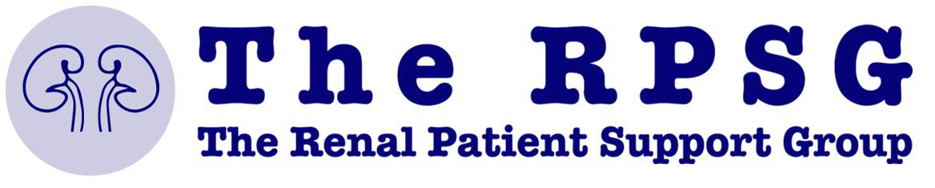
Kidney Disease Awareness Event
28th May 2019, from 10:00 am – 15:00 pm
@
65 High Street Nailsea, Bristol
Light buffet provided
Proposed Agenda
Time | Presentation | Speaker
10:00 – 10:20 | Welcome and Introduction | Ian Morrell  65 High Street, Nailsea
10:20 – 10:40 | The challenges surrounding Health Literacy | Dr. Malcolm Rigler  General Practitioner  Dr Malcolm Rigler FRSPH, Member CILIP Health Group  Project Volunteer @ The Patients Association  www.librariesandhealth.com
10:40 – 12:40 | Kidney Disease Workshop | Malcolm, Shahid and Ade
12:40 – 13:40 | Food and Networking
13:40 – 14:00 | Let’s talk about Kidney Disease in Primary Care | Shahid Muhammad  Specialist Biomedical Scientist  Chartered Scientist  University of the West of England (UWE)
14:00 – 14:20 | Being Positive through Chronic Illness, Chronic Kidney Disease (CKD) | Ade Oliatan  Long-time Patient and CKD Ambassador  Ujima Radio and The Rebel without a Cause (TRWAC)
14:20 – 14:40 | The Work of the RPSG | Vicky and John Gardner  The Renal Patient Support Group (RPSG)
14:40– 15:00 | Kidney Care from a specialty point of view | TBC  Nephrologist

The RPSG will have a stand and handouts. We welcome all who attend to interact with the RPSG team and get an understanding of their wider efforts.

