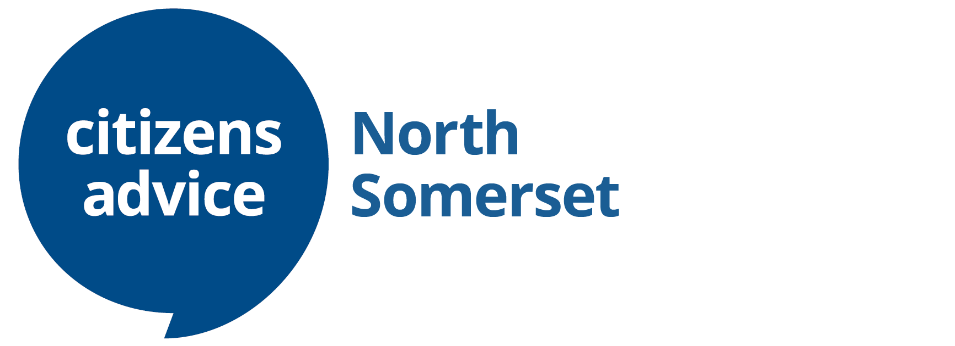

**We have moved**

**with immediate effect**

**our new contact details are:**

**Postal Address:**

**PO Box 678, Weston-super-Mare BS23 9QA**

**Registered Office Address:**

**Old Village Hall, 25 Old Street, Clevedon BS21 6ND**

**Weston-super-Mare Advice Service**

**Unit 3, The Sovereign Centre, Weston-super-Mare, BS23 1HL**

**Email Advice:** [**advice@nscab.org.uk**](mailto:advice@nscab.org.uk) - response within 5 working days

**Online Advice:** [**www.citizensadvice.org.uk**](http://www.citizensadvice.org.uk)

**For more information about our advice services please visit our website:** [**www.nscab.org.uk**](http://www.nscab.org.uk)

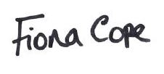

**Fiona Cope ~ Chief Officer**

Registered Office: Old Village Hall, 25 Old Street, Clevedon BS21 6ND

Postal Address: PO Box 678, Weston-super-Mare BS23 9QA

Citizens Advice is the operating name of North Somerset Citizens Advice Bureau

Charity registration no. 1052967 VAT no. 752795494

Authorised and regulated by the Financial Conduct Authority FRN: 617686

Company limited by guarantee registered no. 2906303





